Health care spending compared to other countries
29 January 2015 Kings Fund
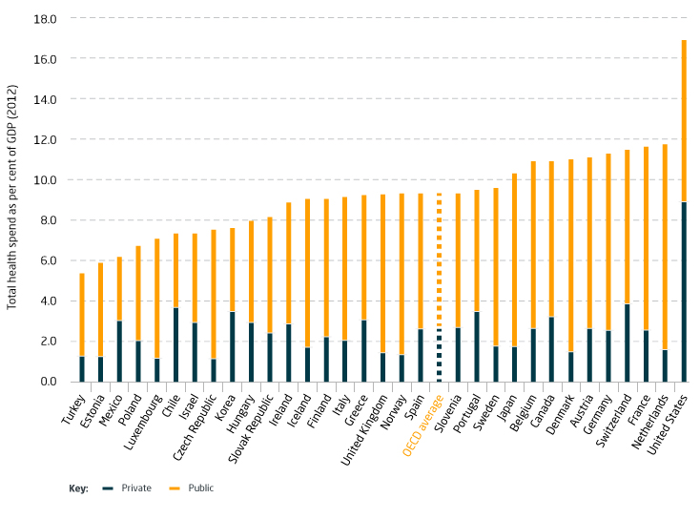
Source: OECD Health Data 2014
UK spending as a proportion of GDP lagged behind spending in other OECD countries for many decades but by 2012 it was on a par with the OECD average of 9.3 per cent following decisions to boost NHS spending between 2000 and 2009. This still means that UK spending is lower than other countries that many may wish to compare it against, such as the Netherlands, France, Germany and Canada.
This data includes private spending on health care which in the United Kingdom is only 1.5 per cent against an OECD average of 2.6 per cent.

The NHS budget and how has it changed
29 January 2015
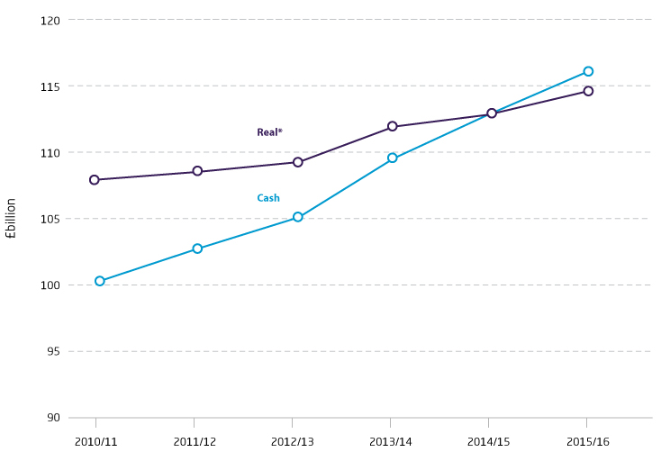
Source: Department of Health Annual Reports and Accounts 2013-14 and Autumn Statement 2014.
*Real figures are in 2014/15 prices and adjust cash spending for inflation as measured by the GDP deflator.
Including an additional in-year increase from Treasury reserves of £250 million, the total budget for the NHS in England for 2014/15 was £113 billion. In 2015/16 this is planned to rise to £116.4 billion (this includes an additional rise of £1.29 billion announced in the 2014 Autumn Statement).
Allowing for general inflation in the economy, this represents an average real-terms increase of 0.9 per cent per year from 2010/11 to 2015/16, or 0.8 per cent over the current parliament (2010/11 to 2014/15). This is the lowest average annual change of any parliament, contrasting with average annual increases of 5.7 per cent under the Labour administrations between 1997/8 and 2010/11 and 3.2 per cent under the Conservative administration between 1979/80 and 1996/7.

How the NHS is funded
29 January 2015
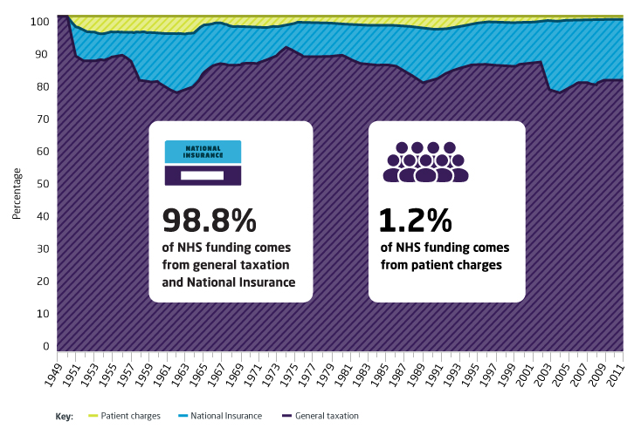
Source: OHE Guide to UK Health and Health Care Statistics
The NHS is mainly funded from general taxation and National Insurance contributions. Small amounts each year come from patient charges for services like optical care, prescriptions and dental care. The decision about how much money parliament will give to the Department of Health to spend on the NHS in England is made as part of the Spending Round process.
While the NHS has never been entirely publicly funded, the percentage of funding from National Insurance and general taxation is at an all-time high. An increase to National Insurance rates in 2001, designed mainly to give a boost to NHS funding, led to the balance between National Insurance and general taxation changing, although general taxation still accounts for around 80 per cent of all NHS funding.

Public satisfaction with the NHS
29 January 2015
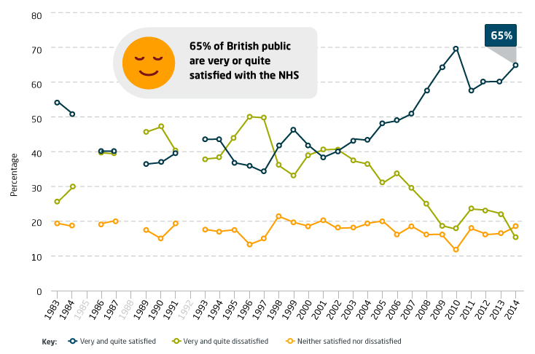
Source: British Social Attitudes survey 2014
Public satisfaction with the NHS is currently high by historic standards. After rising steadily throughout the 2000s, satisfaction reached an all-time high of 70 per cent in 2010. However, 2011 saw the largest drop in satisfaction ever recorded by the survey, down to 58 per cent. Following two years in which satisfaction levels remained largely unchanged, the data for 2014 shows an increase to 65 per cent, the second highest level since 1983.
These changes may represent a genuine feeling among the public about whether the health service is improving or not. However, we know that what drives changes in satisfaction is not straightforward – and almost certainly is never simply satisfaction with the NHS per se, for all respondents to the survey. Political beliefs, attitudes towards the government of the day, media stories and expectations of the NHS all shape people’s feelings of satisfaction.

